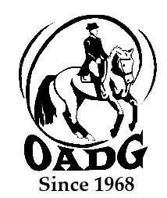

2025 OADG External Score Submission Form
Must be submitted by deadline on OADG website

You may email this form to save paper & time

This form is not required if you are showing at any local show sponsored by the OADG: Silver, Gold or Platinum (FEI/CDI).

This form is required if you have an external show score to report from Silver or Gold circuits.

If you are submitting scores for the Young Horse Award, please use the form entitled “Young Horse Award Form”.

Circuit (underline or circle one): Silver Gold FEI

Division (underline or circle one): Junior AA Open

Level:__________________________________ (Walk/Trot Training, First, Second.....)

Name of Rider: ______________________________________________

Name of Owner: _____________________________________________
Name of Horse:______________________________________________

Criteria – Please see full criteria details on website www.ottawadressage.ca

Results: Please list your eligible external score (to 3 decimal places).
If your ride was judged by more than one judge, please submit only the combined score.
Include website where scores can be verified (preferred method) or attach copies of the test papers.

Show Location | Date | Class | Judge(s) | Score | Website

Rider’s Signature: ____________________________ E-mail: _______________________________________

Contact Phone Number: ________________

Email to: awards@ottawadressage.ca
(signature not required)

Form must be received by the deadlines.

