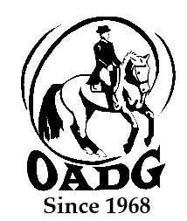
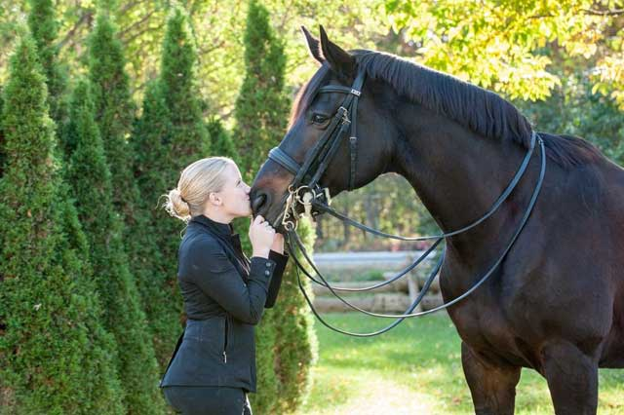

2025 Madison Crich Memorial Adult Amateur Award Submission Form

Must be submitted by deadline on the OADG website

You may email this form to save paper & time

Do you wish to recognize a deserving Adult Amateur horse enthusiast? This Special Award was created to honour the memory of a local and well respected young adult who passed away early in 2015. The person who receives this award is someone who strives to make the dressage community a more positive place. Madison had many friends and admirers in the dressage community and is remembered for her love of the sport and wonderful horsemanship. This yearly award is accompanied by a plaque, and will be presented at the OADG Annual Awards Banquet. Selection will be by nomination accompanied by an essay. Nominees and nominators must be current OADG members.

- A small essay must be written by the nominator on nominee’s positive horsemanship, good sportsmanship and overall love of the horse and the sport. Include how he/she strives to make the dressage community a more positive place.

Name of Nominee: _____________________________________________________

Name of Nominator: ____________________________________________________

Essay: (please use another page)

Nominator’s Signature: __________________________________________________

E-mail: _______________________________________________________________

Contact Phone Number: _________________________________________________

Email to: awards@ottawadressage.ca
(signature not required)

This form must be received by the deadline.

