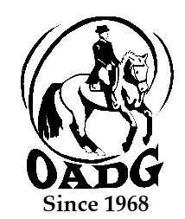

2025 OADG Para-Equestrian Award Submission Form
Must be submitted by deadline on OADG website

You may email this form to save paper & time

This form is required if you are applying for the Para-Equestrian Award. Para-Equestrians must be declared by Equine Canada.

Name of Rider: ______________________________________________

Name of Owner: _____________________________________________
Name of Horse:______________________________________________

Criteria – Please see full criteria details on website www.ottawadressage.ca

Results: Please list your top three (3) eligible results (to 3 decimal places).
If any scores are from external shows, include website where scores can be verified (preferred method) or attach copies of the test papers for those scores.

Show Location | Date | Class | Judge(s) | Score | Website

Sum of top three (3) eligible scores: ____________

Rider’s Signature: _________________________ E-mail: _______________________________________

Contact Phone Number: ___________________________

Email to: awards@ottawadressage.ca
(signature not required)

This form must be received by the deadline.

