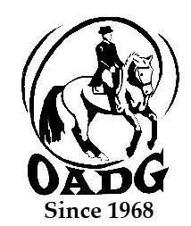

2025 OADG Young Horse Award Submission Form
- Must be submitted by deadline on OADG website

This form may be email to save paper & time

There is one Young Horse Award for each of the three circuits (OADG Schooling, Silver, or Gold). If you are applying for more than one circuit, separate forms must be provided.

Criteria can be found on the website www.ottawadressage.ca

Circuit (underline one): ESD/Schooling Silver Gold

Name of Horse: ______________________________ Age of Horse:________ (must be 6 or under)

Name of Owner: _________________________________________________________________

Name of Rider: ___________________________________________________________________

Results: Please list eligible scores to three (3) decimal places. If your ride was judged by more than one judge, please submit only the combined score. If a score is from external Gold or Silver show please include website here score can be verified (preferred method) or attach copies of the test paper for those scores. NOTE: Only one (1) external score allowed for 2023.

Show Location | Date | Class/Level | Judge(s) | Score | Website

Sum of top three (3) eligible scores: _____________

Rider’s Signature: _________________________ E-mail: _______________________________________

Contact Phone Number: __________________________________

E-mail to: awards@ottawadressage.ca

This form must be received by the deadline.

